StegoHunt User Manual

Nilima Manandhar, Colin Redmond, Eduardo Luna
Department of Information Technology and Management, Illinois Institute of Technology

- GATHERING FILES
1.1. MP3
The mp3 files were gathered from 2 trusted websites: www.mp3subliminals.com and www.youtube.com.audiolibrary/music. Although these are trusted sources we could not be certain that the files are 100% clean. We might risk validity of the project by not ensuring the cleanliness of the files. In order to avoid the risk, the mp3 files were converted to .wav files and back to mp3. What this does is corrupts or destroys any hidden data.
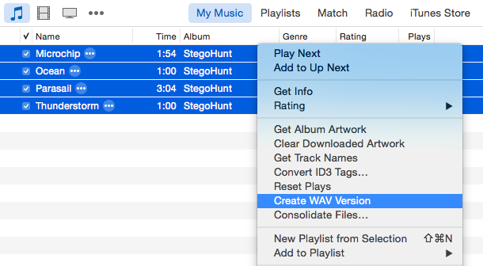
Figure 1 – Creating wav version
The process for converting the files to wav and back to mp3 was simple. Using iTunes go to File > Preferences and select “import settings”. Make sure “WAV encoder” is. Then go back to your itunes library and select your mp3 files. Then right click and select “Create WAV Version”. To change back to mp3 go to File > Preferences and go to “Import settings” and Select “MP3 encoder”. Then select all your wav files, right click and select “Create MP3 Version”. The exact specifications of the MP3 files are shown on the right. The files were dirtied using mp3stegazaurus.

1.1.1. MP3stegazaurus
MP3stegazaurus was created by Mikhail Zaturenskiy, a student at IIT in spring of 2009. The UI of the program is shown in Figure 2.

- To begin first select “Select MP3s”
- Then “Select Data File” to select a data file to hide.
- Make sure Inject is selected at the top right.
- For this project the following were selected “Headers”, “Side Info”, “Empty Frames”, and “Ancillary”
- Make sure to select “Create Backup of Mp3 file” and “FIll in Random Data”
- Then Press “INJECT” to finish.
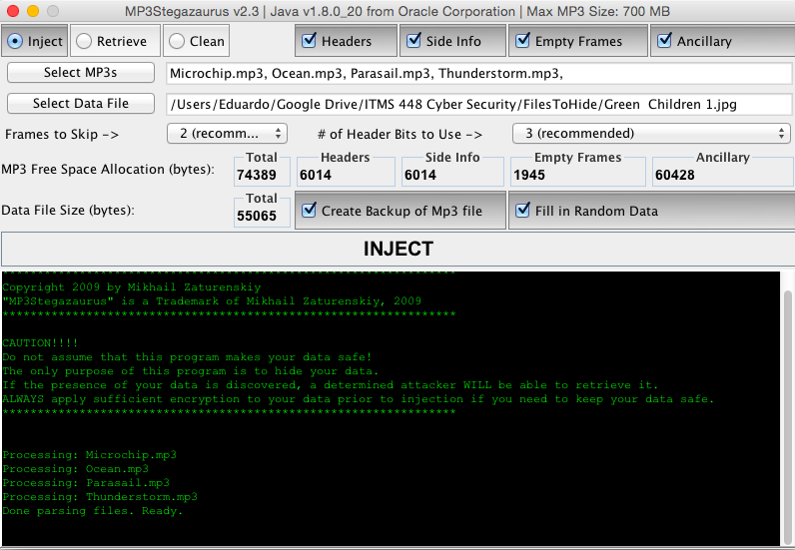
Figure 2 – MP3stegazaurus

1.2. BMP
The clean bmp files were created by taking pictures with a digital camera and by capturing screenshot from the screen. Three bitmap files that were used are shown below with their respective file size:
- Image 1; file size = 22.8 MB
- Image 2; file size = 9MB
- Image 3; file size = 4.11 MB
These files were then dirtied using different programs which will be discussed below:
1.2.1. Invisible Secrets
Invisible Secrets was retrieved from http://www.invisiblesecrets.com/download.html.

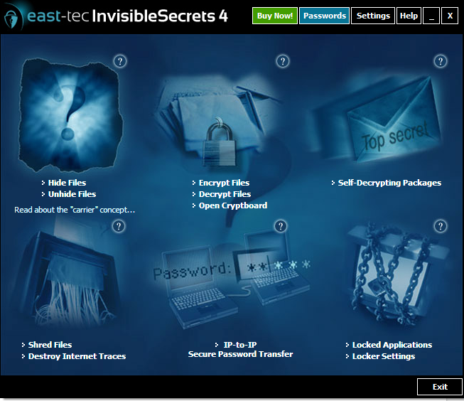
Figure 3 – Invisible Secrets

- To dirty the files, go to Hide Files.
- Choose a carrier file.
- Choose the file to embed.

1.2.2. OpenPuff
This program was downloaded from http://embeddedsw.net/OpenPuff_Steganography_Home.html
After installing it, OpenPuff application was opened. The GUI[Graphical User Interface] for OpenPuff is shown in the figure 4 and 5.

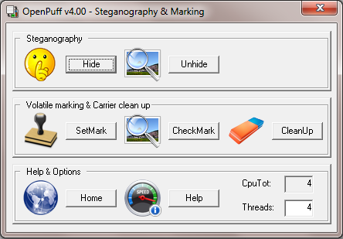
Figure 4 – OpenPuff (Steganography & marking)

Figure 5– OpenPuff (Data Hiding)

In order to embed hidden files using OpenPuff, click “Hide”, and it should display the GUI as shown in figure 4.

1.2.3. SecretLayer
SecretLayer can be downloaded from http://www.steganographypro.com/. After installing this application, execute the Secret Layer. You should see a GUI as shown in figure 6.

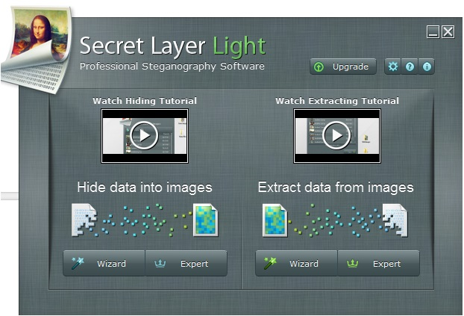

Figure 6 – SecretLayer

To embed a file, click on the “Wizard” button. It should open a new window that allows to “add container images”. Click on “Add Images” to insert your carrier file and press “Next”. Upon pressing “Next”, a new window is displayed which allows the user to “add data to hide”. Add the files that you wish to embed by clicking on the “Add Files” Press “Next” and here you will have a new window where you can encrypt.This step is optional. Press “Next” and provide a path to save your dirty file and press “Hide”. After a successful attempt, you should receive a window that confirms that data has been hidden.

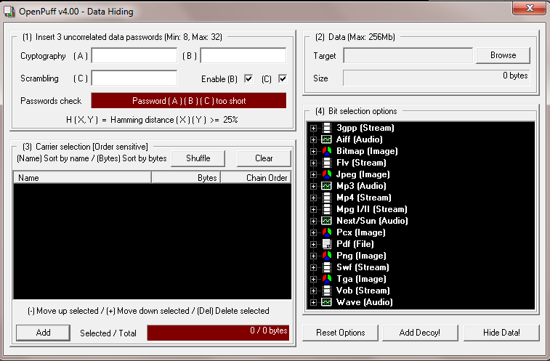
1.2.4. StegHide
StegHide can be retrieved from http://steghide.sourceforge.net/download.php. Upon installation, open StegHideUI. The GUI for StegHideUI is displayed in figure .
- Choose the carrier file by clicking on the “browse” button on the Covert File.
- Choose the file to embed by clicking on the “browse” button on the “Embed File”.
- Choose the path where you want the dirty file to be stored.
- Click “Embed”
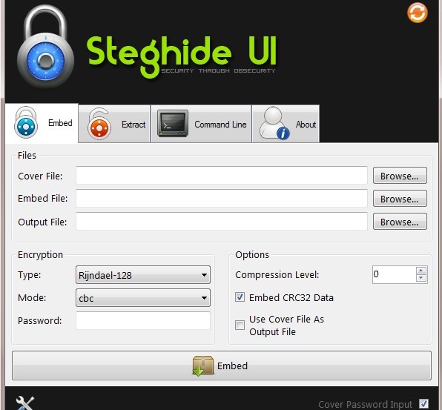
Figure 7 – Steghide UI
1.3. JPG
The clean jpg files were created by using a digital camera and by taking a screenshot from the desktop. The files were dirtied using the following programs :
1.3.1. Invisible Secrets
- To dirty the files, go to Hide Files.
- Chooes a carrier file.
- Choose the file to embed.

1.3.2. JPHS
JPHS can be downloaded from http://linux01.gwdg.de/~alatham/stego.html. After installing it, open the jphswin application. The GUI for JPHS is displayed in figure: .
To dirty the files following steps were followed:
- Click on “Open jpeg” and select the carrier file.
- Click “Hide”.
- It should display “Enter the pass phrase and confirmation”. Enter a pass phrase.
- Choose the file to embed.
- Choose “Save jpeg as” and choose the path where you wish to save the file.

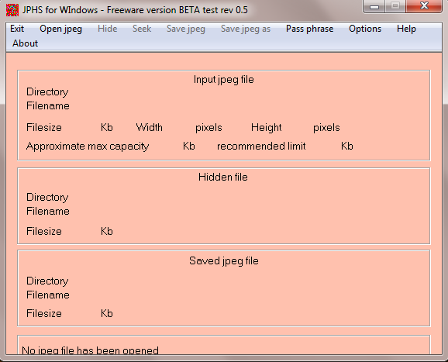

Figure 6 – JPHS

1.3.3. OpenStego
OpenStego can be retrieved from http://sourceforge.net/projects/openstego/files/. After installing it, open the OpenStego application. In order to hide a carrier file, the following steps were followed:
- Click on “Hide Data”
- Under the Message File, browse for the file to embed.
- Under the Cover File, browse for the file for the carrier file.
- Under the Output Stego File, browse for the path where you want to hide the dirty file.

1.4. DOCX
The Docx files where created in Microsoft Word 2007 by copying text from various websites to the clipboard then pasting them the various Word Docx files. The files where dirtied using the following methods/applications.

1.4.1. 7Zip
7-Zip is a multi-use open source archiving software available for free download from http://www.7-zip.org

In order to hide a carrier file, the following steps were followed:
- Download and install 7zip (the 32 or 64 version bit as needed).
- Right click on the overt (target) file.
- Select "Open Archive" from the "7zip" menu option.
- A window should open, drag and drop the file you wish to hide into this window and click "yes" to add it to the archive.

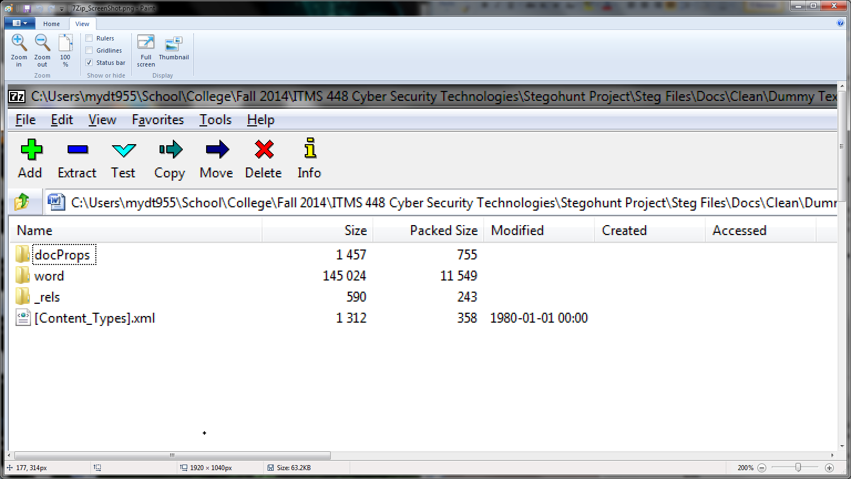
Figure 7 – 7Zip

1.4.2. ooXML_Steganography_Hider
ooXML is part of the ooXML_Steganography software suite written by username "joakim" that can hide and unhide data in an archive file's extra field. It can be obtained at http://reboot.pro/files/file/102-ooxml-steganography

In order to hide a carrier file, the following steps were followed:
- Download ooXML_Steganography_v4 and run ooXML_Steganography_Hider.
- Click the "Browse" button next to "Select target file you want to hide" then browse to the file you wish to hide.
- Click "Prepare secret data".
- Click the "Browse" button next to "Select archive as container" then browse to your overt file.
- Depending on the size of the prepared secret data, method 1 - 4 will be made available or grayed out.
- Available archives will be shown in the dropdown box, Select one.
- Click "Prepare archive".
- Click on "Hide file".
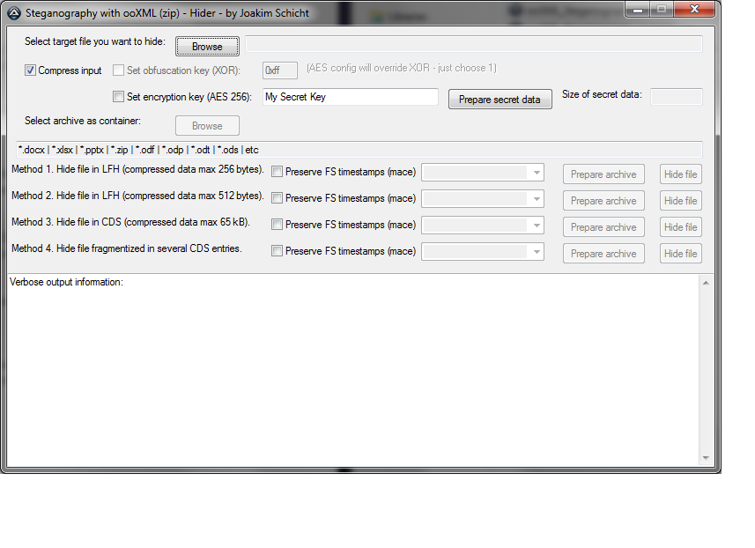

Figure 8 – ooXML_Steganogrphy_Hider

1.4.3. ooXMLSignatureTweaker
ooXML SignatureTweaker an application written by username "joakim" that allows a user to hide data in the signatures that can be generated in Microsoft Word. It can be download from http://reboot.pro/files/file/103-ooxmlsignaturetweaker

In order to hide a carrier file, the following steps were followed:
1. Ensure that your overt (target) .docx file has a signature applied to it.

2. Download and run ooXMLSignatureTweaker_v1002

3. Click the "Browse" button next to "Select target file (container)" then browse to your overt file.

4. Click the "Browse button next to "Select secret data (payload)" then browse to the file you wish to hide.

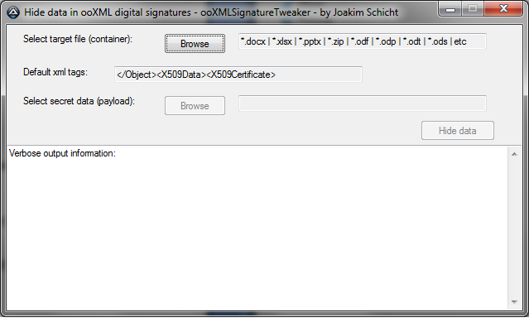
Figure 9 – ooXMLSignatureTweaker

- USING STEGOHUNT
StegoHunt is a tool used for finding the existence of hidden data.

In order to detect carrier files, the following steps were followed:
- Click “Add Directory”.
- Browse to the directory where your carrier files are located.
- After having added your desired directories and having selected them by checking the boxes, click “Find Carriers”.
- Select where you would like the report to generate and click confirm to run your carrier files through StegoHunt.
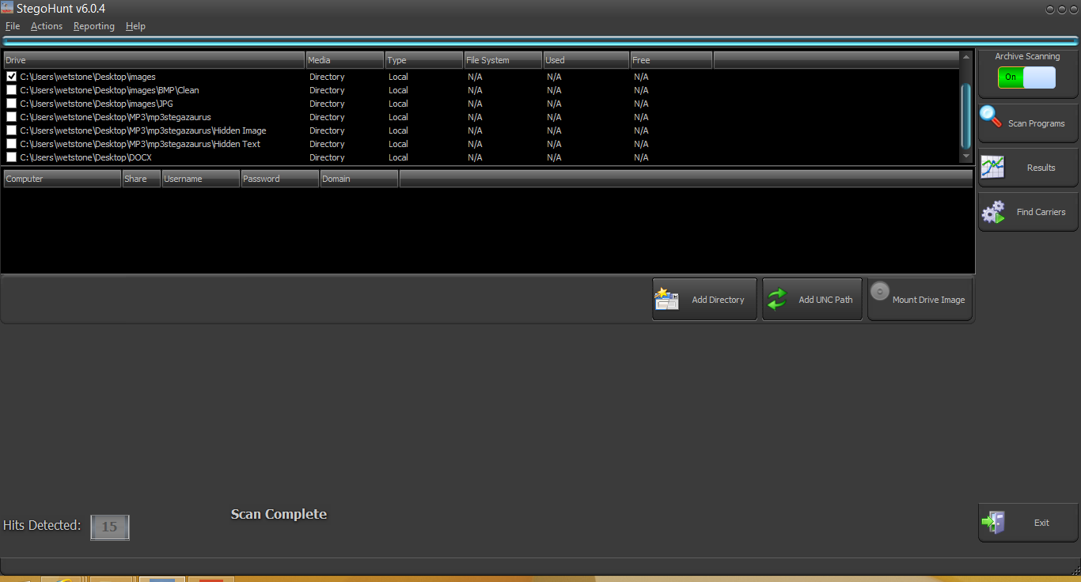
- Wait for your scan to complete.
Figure 10 – StegoHunt

